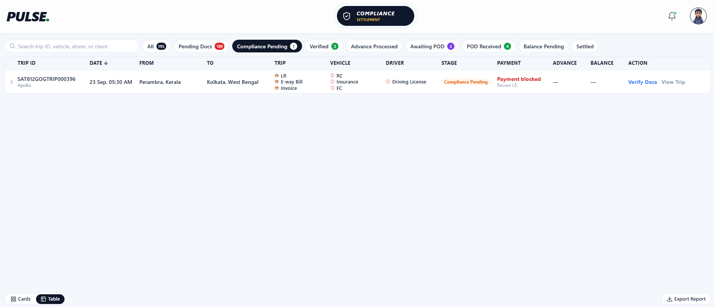
1. E-way Bill Details in Compliance Table
The Trip Ops team enters the E-way Bill details for the respective trip in the Trips page.
In the Compliance page – Table View, I require the following E-way Bill details to be displayed:
- E-way Bill Number
- E-way Bill Expiry Date
These should be added as a separate column positioned between the “To” and “Trip” columns.
2. Trip, Vehicle & Driver Status Display
Currently, under the Trips column, the system displays “LR/Eway Bill/Invoice”.
Instead of displaying the document names, the column should display only the overall verification status:
- Pending – displayed in red
- Approved – displayed in green
The status should also be clickable/interlinked with the respective document verification page.
Expected Flow:
- If the required documents have not been approved, display Pending in red.
- Click Pending → Open the respective document verification page.
- After reviewing and approving all required documents, the status should change to Approved in green.
- Once approved, returning to the Table View should automatically reflect the updated Approved status.
The same functionality should be implemented for:
- Trips
- Vehicle
- Driver
This will make the Compliance Table View cleaner and allow the verification status to be identified quickly.
3. Action Column – Verify & Hold
Currently, the Action column contains:
- Verify Docs
- View Trips
Remove “Verify Docs” and “View Trips”.
The Action column should contain only:
- Verify
- Decline
Verify Action
When the user clicks Verify:
- The system should verify the trip.
- The trip should be removed from the Compliance Pending page.
- The trip should automatically move to the Verified page.
Decline Action
When the user clicks Decline:
- A popup/modal should appear asking for the Decline Reason.
- The user must enter the reason before proceeding.
- The entered reason should be stored against the trip for future reference.
- After submitting the reason, the trip should remain in the Compliance Pending page.
- The Decline status/reason should be available for tracking and review.
Important: A Decline action should not move the trip out of the Compliance Pending page.

